MAJOR PROJECTS COMPLETED DURING INDUSTRIAL TRAINING

PROJECT 1: GLOBAL VIDEO GAME SALES ANALYSIS USING PYTHON

1. Project Overview

The first major project completed during the industrial training was “Global Video Game Sales Analysis: Exploratory Data Analysis and Market Intelligence.” The objective of this project was to analyze historical video game sales data and extract meaningful insights related to game genres, publishers, platforms, regional sales, and overall global performance.

The project used a Kaggle video game sales dataset containing 16,598 records and 11 columns before cleaning. The analysis followed a complete data analytics workflow, beginning with dataset collection and preprocessing and continuing through exploratory data analysis, visualization, feature engineering, and interpretation of results. The project was developed using Python, Pandas, NumPy, Matplotlib, Google Colab, and Kaggle.

2. Data Cleaning and Preprocessing

The raw dataset contained missing values, particularly in the Year and Publisher columns. Using Pandas, the dataset was inspected with functions such as "info()" and missing-value analysis. The dataset initially contained 16,598 rows, with missing values identified in the Year and Publisher fields.

Data cleaning was performed to improve the quality and reliability of the analysis. Missing and incomplete records were handled, resulting in a cleaned dataset containing 16,540 rows and 11 columns. The cleaned data included fields such as Rank, Name, Platform, Year, Genre, Publisher, NA_Sales, EU_Sales, JP_Sales, Other_Sales, and Global_Sales.

3. Exploratory Data Analysis

Exploratory Data Analysis was performed to identify patterns and relationships within the dataset. Different statistical and graphical techniques were used to analyze regional sales, game genres, publishers, platforms, and individual game performance.

The analysis showed that Action was one of the leading genres in terms of global and European sales. The dataset was also examined to identify highly successful games and publishers. Visualizations were created using Matplotlib to make the results easier to understand.

4. Data Visualization and Insights

Several visualizations were created, including bar charts, distribution charts, and comparative plots. These visualizations helped identify:

- Sales performance across different game genres.
- Top-performing video games based on global sales.
- Regional differences between North America, Europe, and Japan.
- Publisher-wise sales performance.
- Popular game categories and platforms.
- Relationship between regional sales and overall global sales.

-The analysis demonstrated how raw historical data can be transformed into meaningful information for understanding the video game market.

5. Project Workflow

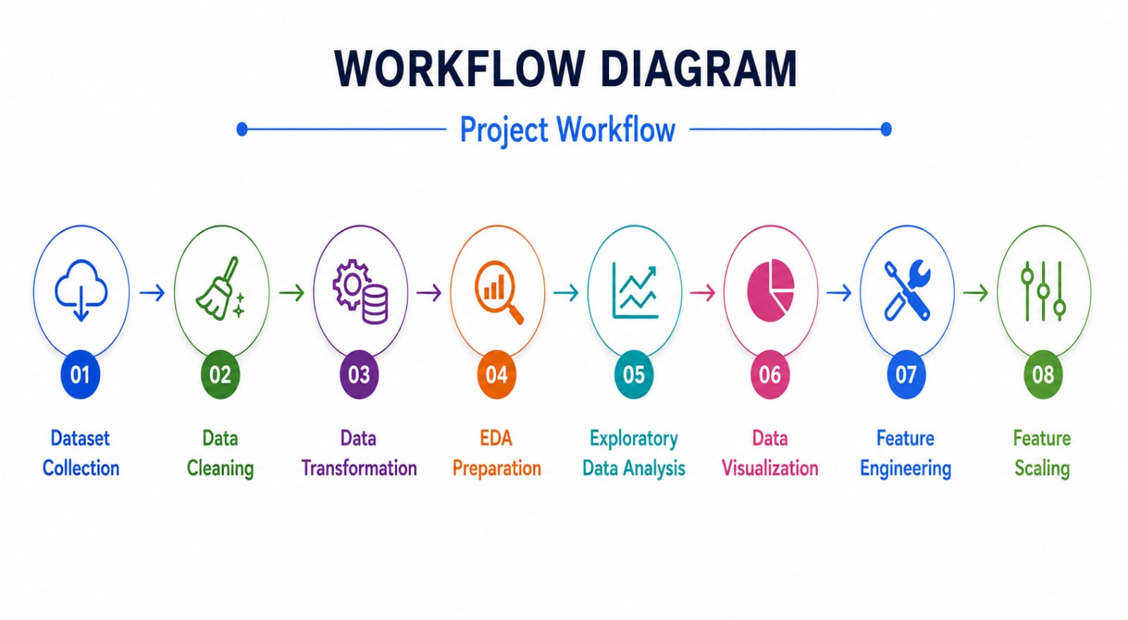

6. Outcome

This project provided practical experience in handling a real-world dataset and applying the complete data analysis process. It strengthened skills in Python programming, Pandas-based data cleaning, exploratory analysis, visualization, feature engineering, and insight generation. The project also demonstrated the importance of data preprocessing before performing analytical and visualization tasks.

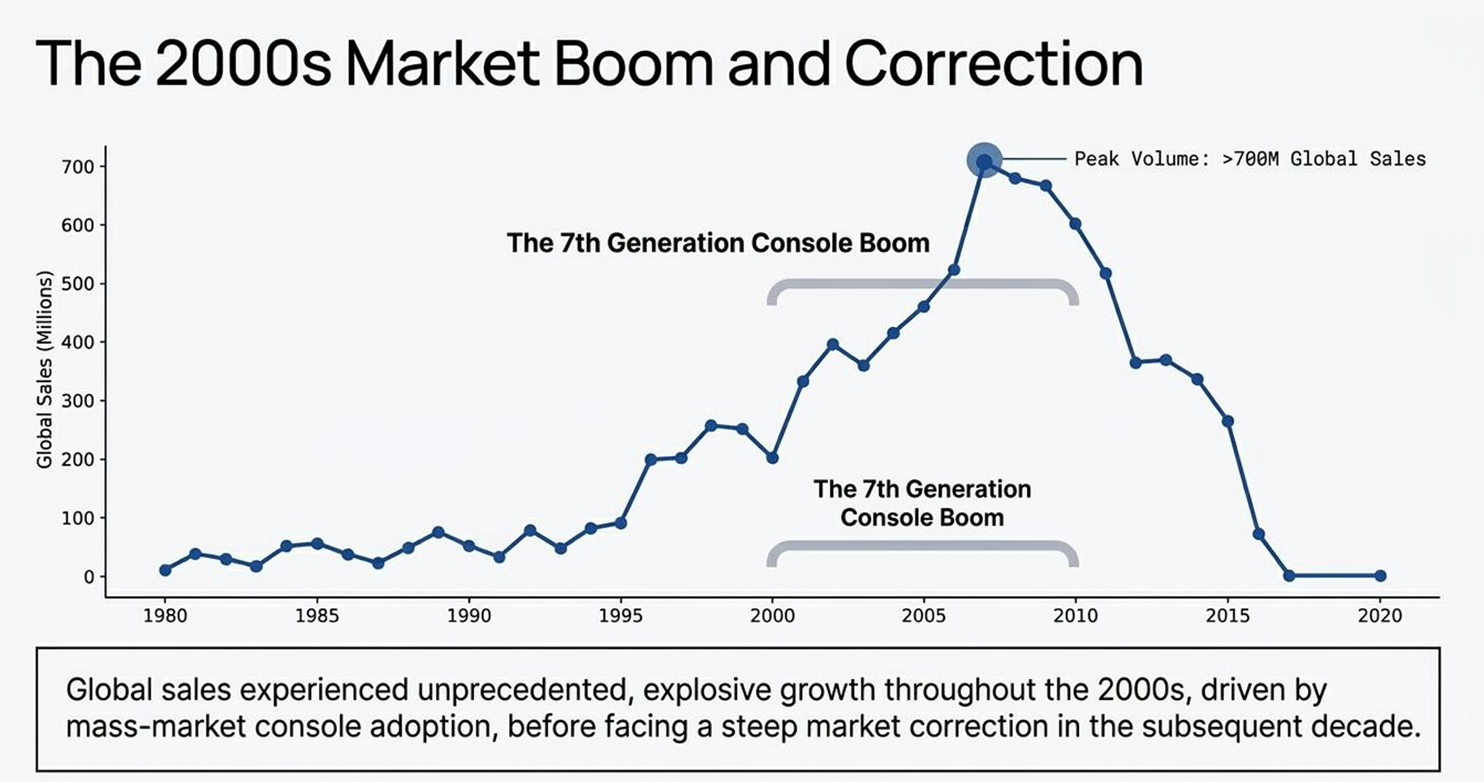
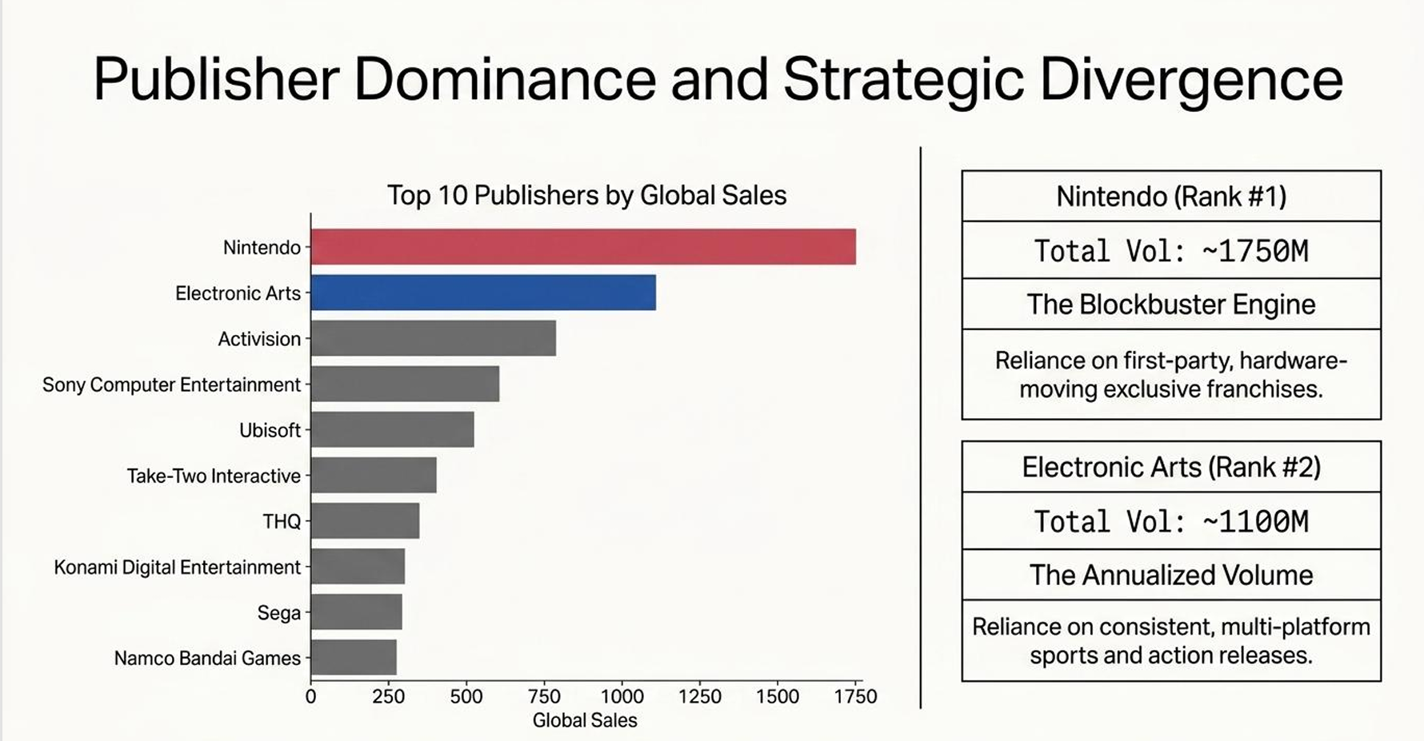

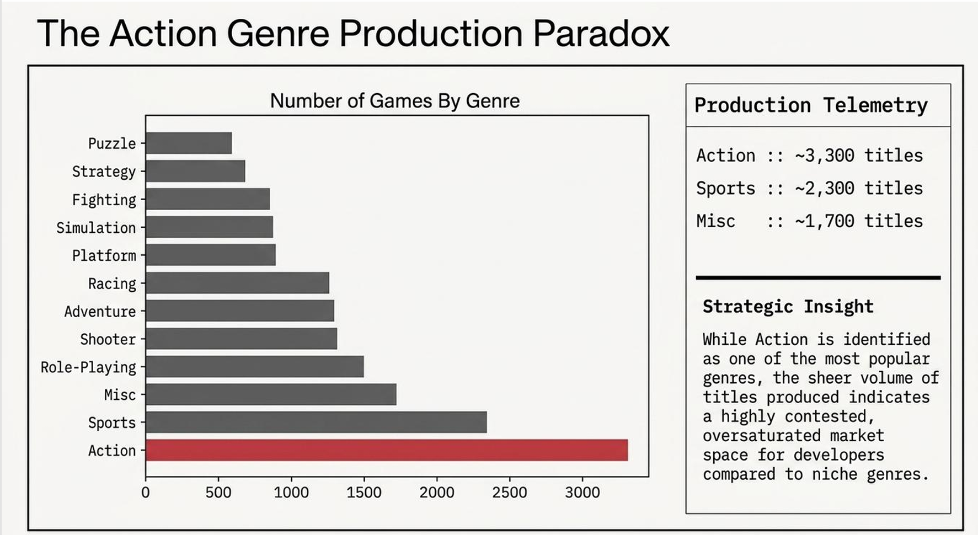

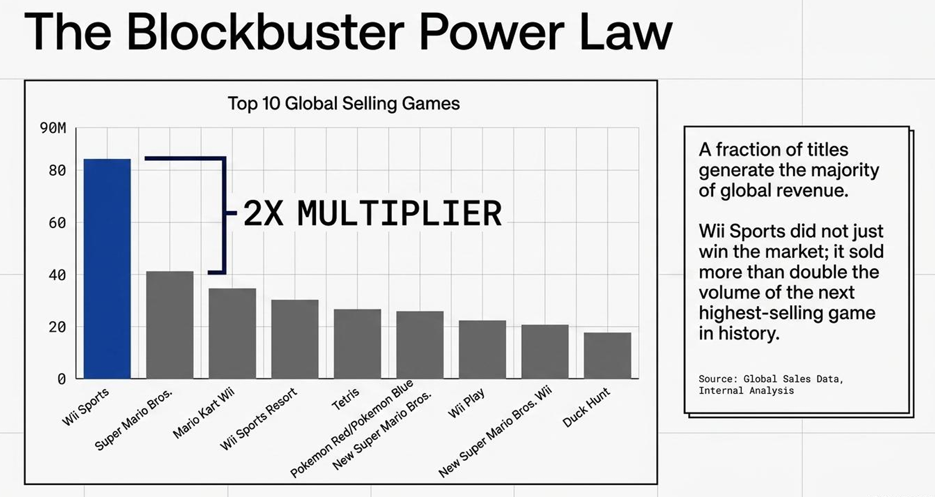PROJECT 2: GLOBAL EV CHARGING STATIONS INFRASTRUCTURE ANALYSIS USING POWER BI

1. Project Overview

The second major project was “Global EV Charging Stations Infrastructure Analysis.” This project focused on developing an interactive Power BI dashboard to analyze electric vehicle charging infrastructure across different countries and regions.

The dashboard was designed to provide an executive-level overview as well as detailed infrastructure analysis. It contains multiple analytical pages covering station operations, country distribution, charging operators, connector types, charging capacity, regional distribution, and individual station details. The project used Power BI Desktop, Power Query Editor, and DAX.

2. Data Preparation and Transformation

The project began with raw EV charging station data. The data was cleaned and standardized to handle missing values, duplicates, inconsistent country names, operator names, station status, and connector information.

Power Query Editor was used for data transformation and preparation. Validation was performed for important fields such as location, station status, and connectivity information. Charging connectors were also transformed into useful analytical categories.

3. DAX and Dashboard Development

DAX was used to create calculated columns and measures required for dashboard analysis. The resulting data model was used to build an interactive Power BI report containing three major pages:

1. Executive Overview
2. Infrastructure Analysis
3. Station Details & Drillthrough Analysis

The Executive Overview provides key performance indicators such as approximately 10K total stations, 9K operational stations, 626 non-operational stations, 93.46% operational percentage, and 14K total connectors. The dashboard also displays country-wise station distribution and operational status.

4. Infrastructure Analysis

The Infrastructure Analysis page examines charging operators, country regions, connector types, charging capacity categories, and station status.

The analysis identifies Circuit Electrique as the leading charging operator among the displayed operators. The charging capacity analysis shows that Small charging stations form the largest category, followed by Medium and Large stations. Country and regional analysis provides a geographical understanding of the EV charging infrastructure.

5. Station Details and Drillthrough

The Station Details page provides detailed station-level information including:

- Station ID
- Country Name
- Charging Operator
- Total Connectors
- Operational Flag
- Charging Capacity Category
- Country Region
- Operational and non-operational station counts

The drillthrough functionality allows users to move from high-level dashboard information to detailed station-level records. The report contains 9,570 stations, including 8,944 operational stations and 626 non-operational stations in the summarized regional data.

6. Outcome

This project provided practical experience in Business Intelligence, Power Query, DAX, data transformation, interactive visualization, KPI development, dashboard design, and data-driven decision-making. The completed dashboard converts raw EV charging infrastructure data into an interactive analytical report that can support infrastructure monitoring and comparative analysis.

Project Workflow

